C3-S4-PRACTICE

# What you will know:

LIKE - DISTINCT

Open [this online SQL editor](https://www.w3schools.com/mysql/trymysql.asp?filename=trysql_select_columns)

Look at the content of the **Customers** table, using a SQL command or by clicking on the link on the right side

**Q1**: Show all the **different** countries the customers come from

Expected columns:

Country

**Your query:**​ SELECT DISTINCT(Country) FROM Customers;

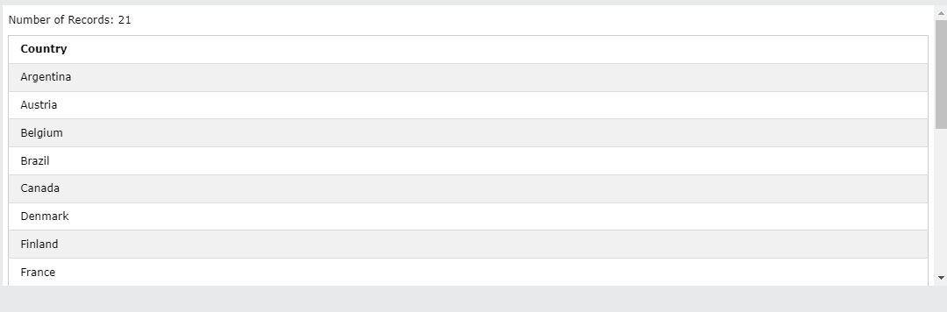

**Q2:** Show all the customers from Germany whose name starts with "D"

Expected columns:

CustomerName Country

**Your query:** SELECT CustomerName, Country FROM Customers WHERE CustomerName LIKE "D%" AND Country="Germany";

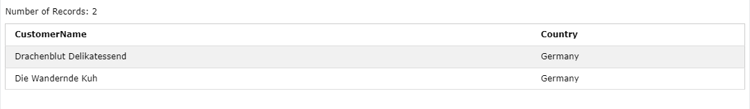

**Q3:** Show all customers from Germany whose name starts with "D", **together with** all customers from Mexico whose name **does not** start with "A"

Expected columns:

CustomerName Country

**Your query:** SELECT CustomerName, Country FROM Customers WHERE CustomerName LIKE ("D%") OR CustomerName LIKE ("%A") AND Country=("Germany") OR Country=("Mexico") ;

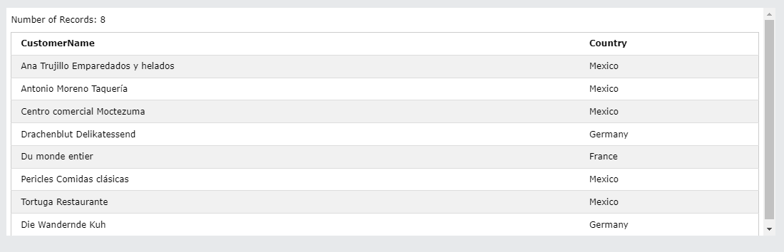

**Q4:** Show all customers from Germany whose id is less than 40, together with all customers from Mexico whose id is greater than 50

Expected columns:

CustomerName Country

**Your query: SELECT CustomerID, Country FROM Customers WHERE CustomerID = 40 OR CustomerID = 50 AND Country="Germany" OR Country="Mexico";**

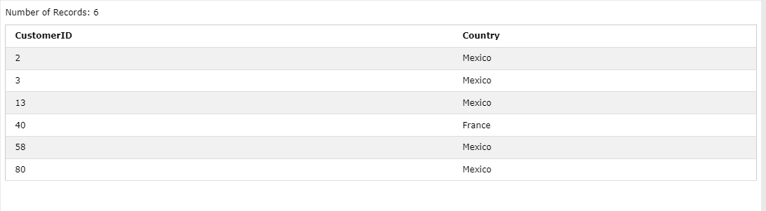

**Q5:** Show all customers from France whose name starts with ‘B’ together with customers from France who do not come from Paris

Note: Customer from France, not coming from Paris and having a name starting with “B” shall appear only once on this result

Expected columns:

CustomerName City Country

**Your query:**

**Q7:** Display the different cities of customers from France or whose name starts with “B”

Expected columns:

City

**Q8:** Display all customers whose name starts with letter ‘*s*’ and ends with letter ‘e’.

Expected columns:

CustomerName

**Your query:**

**Q9:** Display all customers whose name contains ‘er’

Expected columns:

CustomerName

**Your query:**

**Q10:** Display all product name that the second letter is ‘L’.

Expected columns:

CustomerName

**Your query:**